Boy Scouts of America

Middle Tennessee Council

Cogioba District

Cub Scout Pack 516

416 Church Street

Clarksville, Tn 37040

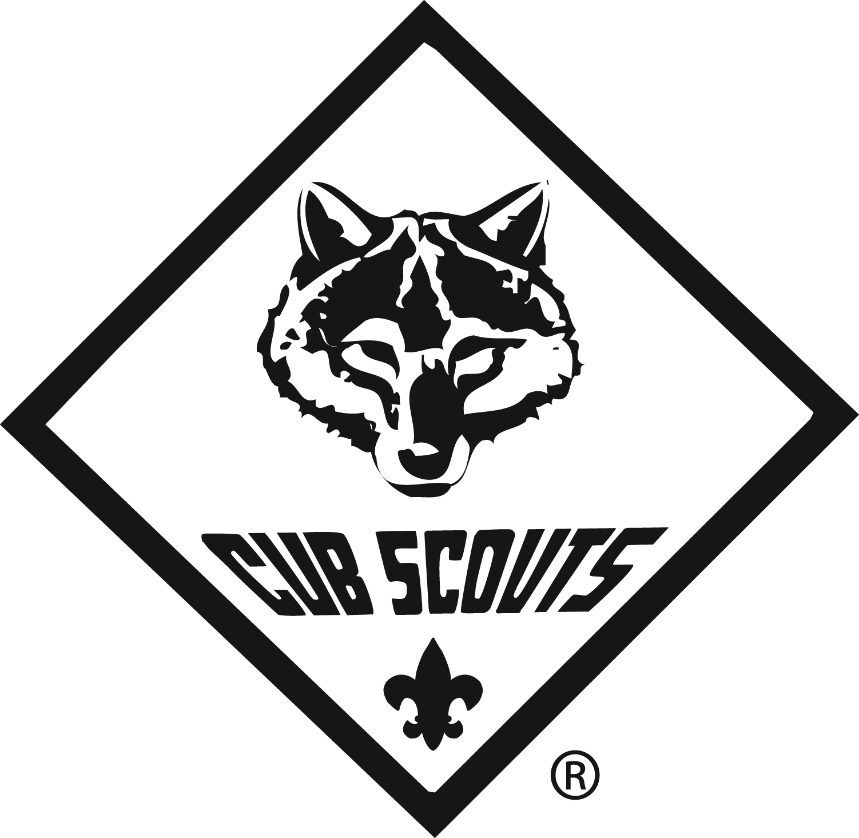

Cub Scout Camping

Camping is the great outdoor adventure of the Boy Scouts of America. Organized camping is a creative, educational experience in cooperative group living in the outdoors. It uses the natural surroundings to contribute signiﬁcantly to physical, mental, spiritual, and social growth.

Camping offers many beneﬁts.
- It contributes to good health through supervised activity, sufﬁ cient rest, good fun, and wholesome companionship.
- It helps campers develop self-reliance and resourcefulness by providing learning experiences in which they acquire knowledge, skills, and attitudes essential to their well-being.
- It enhances spiritual growth by helping campers recognize and appreciate nature and the handiwork of God in nature.
- It contributes to social development by providing experiences in which campers learn to deal practically and effectively with living situations.
- It is an experience in citizenship training, providing campers with opportunities to make decisions and plan and carry out activities at their own level, while improving understanding within the family.

At the Cub Scout level, it introduces boys to the knowledge and skills that they will learn and apply more thoroughly as a Boy Scout. Cub Scout camping provides experiences that are age appropriate for Cub Scouts and their families. The ideal method of camping for Cub Scouts involves parents/guardians and the pack by dens. As with other outdoor activities, it’s important that camping trips be age appropriate. It’s also important to understand who can lead certain types of camping experiences, where they can be held, and what training is required.

CAMPING HEALTH AND SAFETY

Where to Camp:

Cub Scout pack camping should be conducted only at sites approved by the local council. This might include federal, state, or local parks, in addition to BSA property. Check with the local council service center for locally approved sites before planning your trip. Obtain appropriate tour permits and licenses required by the site and the local council. Webelos Scouts should participate in family-type camping, as opposed to the more challenging type of camping that they will experience as Boy Scouts. A location like a Scout camp or public campground that has a tested water supply, toilets, cooking facilities, space for pitching tents, and an area for indoor activity would be appropriate for a Webelos den overnight campout.

Water

Use only tested water for drinking. Packs will camp in approved council sites that usually have good facilities and tested water. If the water at the camping site hasn’t been tested, bring water from home in plastic jugs or other closed-top containers. If in doubt, bring water to a full rolling boil for at least a minute. Allow enough for drinking water, cooking, and cleanup and have some extra for ﬁre protection.

Sanitation

Pack overnighters should be held at a site that has toilet facilities.

Dishwashing is often a problem when camping. For a short overnight campout, solve the problem by using paper plates and cups and plastic utensils, leaving only the cooking utensils to be cleaned.

If a trash receptacle isn’t available, carry out the used dinnerware for disposal at home.

Use hot water for cleaning pots, pans, and utensils. Sterilize with boiling water and air-dry. If non-disposable tableware is used, teach the boys to scrape their dishes before putting them in the dishwater. Strain food bits out of your dishwater and put them in your trash. Carry the used water away from camp and at least 200 feet (75 steps) from any lakes or streams. Give it a good ﬂing, spreading it over a wide area.

Campsite Cleanliness

Trash, including food scraps and paper products, should be disposed of properly in a trash receptacle and not burned. Don’t put plastic or plastic foam in a ﬁ re; burning plastic can release toxic gases. Don’t bury leftovers or scatter food in the woods. Animals will ﬁnd it, and it is not healthy for them to eat. If the campsite has garbage disposal facilities, use them. If not, pack it out. Wash bottles and ﬂatten tin cans for recycling. Always take plastic garbage bags on a campout. They serve many purposes, especially if you must carry out trash.

Flammability Warning

No tent material is ﬁreproof; all can burn when exposed to heat or ﬁre. Follow these rules.
- Only ﬂashlights and electric lanterns are permitted in tents. “No ﬂames in tents” is a rule that must be enforced.
- Liquid fuel stoves, heaters, lanterns, lighted candles, matches, and other ﬂame sources should never be used in or near tents.
- Do not pitch tents near an open ﬁre.
- Do not use ﬂammable chemicals near tents; that include charcoal lighter, spray cans of paint, and bug killer and repellent.
- Be careful when using electricity and lighting in tents.
- Always extinguish cooking ﬁ res and campﬁres promptly. Obey all ﬁre laws, ordinances, and regulations.

Campﬁre Safety

Fires should be built only in a designated ﬁre ring provided by the landowner or, with permission, in an off-the-ground ﬁ re pit device. The Cub Scout Leader How-To Book has suggestions on how to build an off-the-ground ﬁre pit.

Follow these guidelines when building a ﬁre.
- Build the ﬁre in the center of a 10-foot circle that is free of ﬂammable materials such as twigs and dry grass.
- Don’t build the ﬁre against a tree or between the roots.
- Keep the ﬁre away from dead logs and stumps and from overhanging limbs and branches.
- Don’t use ﬁrewood that spits sparks.
- Break burnt matches before throwing them away, and be sure that they are “cold out.”
- Never leave a ﬁre unattended.
- Keep a bucket of water, dirt, or sand handy for emergency use.
- When you are through with the ﬁre, put it out. Spread the coals and ashes and sprinkle them with water. Stir and sprinkle until the ﬁre is cold out, which means it feels cold to the touch.

Pack Overnighters

Pack overnighters are pack-organized overnight events involving more than one family from a single pack focused on age-appropriate Cub Scout activities and conducted at council-approved locations. If siblings who are not Scouts participate, the event must be structured to accommodate them. BSA health and safety and Youth Protection policies apply. In most cases, each youth participant will be under the supervision of a parent or guardian. In all cases, each youth participant is responsible to a speciﬁc adult.

Adults giving leadership to a pack overnighter must complete Basic Adult Leader Outdoor Orientation (BALOO); and must be current with Youth Protection training (within the past two years). Check with your district leaders for information about BALOO training in your area. Permits for campouts shall be issued locally. Packs use the Tour Plan Checklist.

Purpose

A quality pack overnighter helps strengthen the relationship between a boy and his family and delivers the promise of adventure that boys dream about when they join Scouting. Well-planned overnighters offer a variety of activities to keep boys excited and involved in an ever-increasing challenge of outdoor adventure. They should always be age-appropriate for the boys participating. Many Cub Scouts will have their ﬁ rst overnighter as a member of your pack. It is critical that you make every effort to help this be the most positive experience it can be for boys. If a boy has a negative experience, he may choose never to go camping again. Cub scouting packs is encouraged to provide their youth members with positive outdoor experiences. The format under which an entire pack can camp is a pack-organized camping activity.

How Often Are They Held?
Overnighters organized by the pack are supplemental to participation in council- and district organized camping opportunities. Some packs choose to organize one or two additional overnighter opportunities during the year, perhaps one in the fall and one in the spring. Wintertime camping activities or outings during potentially inclement weather are discouraged.

Who Attends?
The spirit and premise behind all Cub Scout overnight camping is that the activity is a parent-son event. Plans should always be made to have as many adults as youth participants at the event. If a parent cannot attend, the boy’s family must make arrangements for one of the other parents attending, or for another adult relative or friend, to be a substitute at the overnighter. Each boy should have someone he knows watching out for him. If necessary to accommodate a special circumstance, an adult may be responsible for more than one boy.

Where Are They Held?
Pack overnighters may be held only at locations approved by the local council. In selecting these locations, your council used the Pack Overnighter Site Approval Form, No. 13-508B, to identify good locations that are safe and accessible and have adequate facilities for a pack overnighter. Check with your local council for a list of approved pack overnighter locations. The location must be listed on the tour permit application ﬁled for this activity.

How Do We Get There?
Because a family member or other adult will accompany each Cub Scout, transportation should not be a problem. Cars are best for transportation to the overnighter. Transporting boys in trucks is unsafe and forbidden except in the cab. Individual seat belts are required for each person. Buses are not recommended because chartering transportation could make parents feel less responsible for the trip.

What Equipment Do We Need?
An overnighter requires protection from the weather, equipment for food preparation, and program items to suit the area and activities where the overnighter is being held. Tents, cabins, campers, or camp trailers will be required for shelter. Some camps make tents or sleeping areas available to Cub Scout packs. If not, the responsibility for shelter may be assigned to parents. Many families will have their own tents that they use for family camping, or they can borrow one from a neighbor. Often, a nearby Boy Scout troop will loan tents and other camping equipment to a Webelos den. Dens or packs should not be required to purchase camping equipment. Each parent/guardian and son will also need some personal equipment. Use the Individual Campout Checklist for Pack Overnighter (see www.scouting.org/cubscouts) as a guide.

The type of meal program selected for the overnighter will determine the kind of food preparation equipment that will be necessary. In some cases, each family may choose to bring and prepare its own meals. In other circumstances, the pack may choose to share the load and have the entire group prepare meals together. Minimize the amount of cooking responsibility delegated to Cub Scouts.
The number-one goal of these ﬁrst camping experiences is to make them positive events for everyone. Enjoying fun and simple picnic or family-style meals together is a great start.

Pack Overnighter Preparation
Leader Preparation
1. Take Basic Adult Leader Outdoor Orientation (BALOO), which is required for the pack adult leader planning and leading the overnighter.
2. Select the date and location for the overnighter several months in advance. A pack overnighter should never be a last-minute event. It should be scheduled during the annual pack program planning conference.
3. Make reservations and turn in a tour plan to the local council service center well in advance of the overnighter. Make sure that the local council has approved the selected location.
4. Check on local regulations regarding the use of ﬁ res for cooking and campﬁ re programs.
5. Enlist the help of others in planning the details of the campout. If you aren’t a seasoned camper, be sure to take along someone who has camping experience. More than likely, some of the parents will be campers. If not, ask local Boy Scout leaders for help
6. Communicate. Most problems occur because of a lack of planning or communication. Make a great plan and share it with everyone involved.

Boy Preparation
Preparing the boys goes beyond just telling them that an overnighter has been planned. The period of preparation for the overnighter offers many opportunities to introduce new materials to boys and help them develop useful skills. Here are some examples:
1. Teach the boys the rules of ﬁ re safety. (See the Webelos Scout Handbook for ﬁ re safety rules.)
2. Review the Outdoor Code to help Cub Scouts prepare to be responsible campers.
3. Plan ahead for campﬁre program activities. Ask dens or families in advance to prepare fun, appropriate material to share around the campﬁre.
4. At least one pack meeting before the overnighter, go over the Webelos Scout Overnight Checklist (see www.scouting.org/cubscouts) with the boys and send a copy home with them, along with a letter giving the details about the overnighter.

Adult Preparation
Preparing adults is as important as preparing boys. The end result will be a smoothly run overnighter with everyone knowing what is expected. Information about the trip can best be communicated at a pre-overnighter meeting with the parents. Make this a plan-sharing meeting.

The basic plan is developed, but let parents get involved in planning the details. Enhance the program using their talents and abilities. For example, one parent might know about birds and trees, while another might be a great storyteller or game leader.
This meeting should be at least two weeks before the overnighter; this is close enough to the overnighter date so that last-minute changes in plans can be avoided. If some parents can’t attend, be sure they receive as much information as possible.

The meeting agenda should include the following.
1. Date, location, and starting and ending times of the overnighter. Cover this information in detail. Provide maps if necessary. Decide whether transportation will be on an individual basis or through some other method. Carpooling will save on gasoline costs and parking fees.
2. A complete list of “dos and don’ts” for the overnighter. It’s important to communicate very clearly, in writing, to parents the critical health and safety and Youth Protection policies that must be followed during an overnighter activity. Include information on potential hazards at the location, and review safety procedures regarding tools, ﬁres and ﬁre-starting, use of gas stoves and lanterns, and unauthorized behaviors and activities. Because some parents may be new to Scouting, it’s important to include even the most basic, commonsense policies so that everyone is equally informed.
3. Schedule of events. The overnighter’s success depends on having a planned program of activities. Involve the parents in deciding what type of activities will be included in the campout. Consider the following: nature hike, ﬁshing, swimming, games, conservation activities and projects, a campﬁre program, or a service project. For weekend overnighters, an interfaith worship service is appropriate and recommended. It should be simple and brief.
4. Menu. Keep the menu simple, remembering that in most cases the families attending the overnighter will cook, eat, and clean up together. It’s a good idea to suggest that similar (although not necessarily identical) meals be planned for all involved. Pack wide meals are also recommended and can be very simple. For example, if the overnighter
Begins on Saturday morning, it should start after breakfast, and everyone should bring a sack lunch. Dinner Saturday evening could be a family barbecue, and breakfast Sunday morning could be a pack wide pancake feed. Again, simplicity is the key Special foods that focus on the theme of the overnighter are an easy way to make the campout fun. Examples include a Wild West chili cookout for lunch, where families prepare and share a pot of chili, complemented by a hot dog feed in the evening. Be creative, but also remember KISMIF (Keep It Simple, Make It Fun).
5. Equipment. Each parent or guardian should have a personal equipment checklist. It’s similar to the one given to the boys but would include speciﬁc things that adults will ﬁ nd handy, such as cooking equipment, lawn chairs, cots, tents or other shelter, and items for program activities. It always helps to include items that should not be brought as well, such as ﬁ rearms, alcohol, ﬁreworks, and illegal drugs.
6. Health and safety. Using the Guide to Safe Scouting as a resource, review BSA
Guidelines on
- Drug, alcohol, and tobacco use
- Fuel and ﬁre safety
- Water safety
Secure a Personal Health and Medical Record form, No. 34414, for all youth and adults who will attend the campout

This is a short list of items you must do for your Pack Campout:
- Contact your local council for availability and approval.
- Pack-organized family camping must be held in council-approved camping facilities that meet certain standards (Pack Overnighter Site Approval Form, No. 13-508).
- In most cases, the youth member will be under the supervision of a parent or guardian. At least one adult or youth member of the family must be a registered member of the BSA.
- Non-members (brothers and sisters) may participate if the event is specifically structured to accommodate them.
- At least one pack leader in charge of the overnighter must complete Basic Adult Leader Outdoor Orientation (BALOO, No. 34162) prior to the pack overnighter and be on the campout. Additional guidelines for planning a pack overnighter are found in Chapter 33 of the Cub Scout Leader Book

Note on shooting sports: Archery, BB guns, slingshots, etc., are restricted to Cub Scout day camps, Cub Scout / Webelos Scout resident camps, council-organized family camps or den or at council activities where there is properly trained supervision and all guidelines for BSA shooting sports are implemented. Archery and BB gun shooting sports are not to be used at the pack or den level.

It is important that early camping experiences be successful ones if Cub Scouts are to continue to have a desire to camp as they progress through Scouting. Proper equipment (bought, rented, or borrowed), age-appropriate activities, and careful planning are essential.

Outdoor Activity Safety
Always have a ﬁrst-aid kit handy. If possible, have an adult trained in ﬁrst aid and cardiopulmonary resuscitation (CPR) attends pack functions.
- Encourage boys to use the buddy system so that they are aware of each other’s whereabouts at all times.
- Have a plan for personal or natural emergencies (such as lightning storms, high winds, or ﬂash ﬂoods) that could occur during an outdoor activity. Know where emergency care can be obtained quickly.
- Check out activity locations in advance for hazards.
- Avoid dangers such as buildings in disrepair or under construction, ﬁ re hazards, stinging insects, poisonous plants, improperly used tools, and sports or game equipment that are inappropriate for the age and size of the boys. Accidents can be prevented.
- Select a well-identiﬁed gathering place in the event the group is separated.
- An adult should always supervise when Cub Scouts are around ﬁ res and cooking. If the den is building a ﬁre, clear of all burnable materials a space 10 feet in diameter. Stay away from trees with low-hanging branches. The use of chemical or liquid fuel stoves must be limited to adults.
Sun Safety
The American Academy of Dermatology advises the following protection tips against damaging rays.
- Limit exposure to sun between 10 a.m. and 4 p.m.
- Generously apply sunscreen with a sun protection factor (SPF) of at least 15.
- Wear protective, tightly woven clothing.
- Wear a 4-inch-wide broad-brimmed hat and sunglasses with ultraviolet (UV) protective lenses.
- Stay in the shade whenever possible.
- Avoid reﬂective surfaces, which can reﬂect up to 85 percent of the sun’s damaging rays.
Hiking Safety
Hikes are simple and informal activities that don’t require a lot of preparation. Certain safety precautions, however, need to be followed whenever Cub Scouts are in the outdoors.
- Avoid highways. When walking along any road, have the group walk single ﬁle as far to the left as possible, facing oncoming trafﬁc. The den leader should be the ﬁrst in line, with the den chief or an adult at the end.
- Keep the hike speed consistent with the short steps of the boys. It can help to put the slowest hiker near the front. Exhaustion is a common complaint. Some boys can go on endlessly whereas others tire quickly. Take frequent rest stops. Use the time to talk about nature, play quiet games, or eat snacks.
- Never drink untested water. The safest water supply is a supply of water brought from home.
- Stay off private property unless you have permission.
- Stay away from railroad tracks.
- Avoid natural hazards such as fast-moving streams, steep cliffs, caves, and areas with loose rocks.
- Plan all hikes to start and ﬁnish during daylight hours. Any Cub Scout hike should be a day trip only. Overnight backpacking is not an appropriate activity for Cub Scouts or Webelos Scouts.

