This document outlines how to access the Pack 485 ScoutLander Web Site. The website is very intuitive and easy to use. For any questions, please email CubScoutsPack485@gmail.com.

Instructions:

1. Open a browser and go to: http://www.scoutlander.com/publicsite/unithome.aspx?UID=14049

2. Click on Member Login on the top toolbar
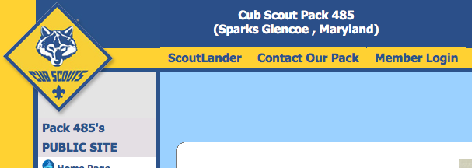

3. Enter your Email and Password then click Login

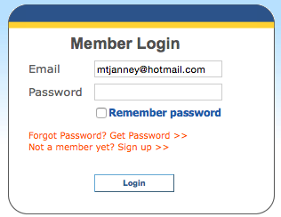

4. Once you login, click on the hyperlink for the site you have access to.
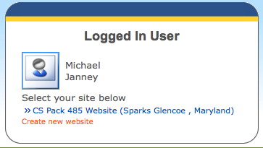

5. After clicking the link - click on Home Page under Public Site on the left column.
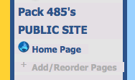

Once you logged in, you may wish to update your profile information on the left side of the site under “My Profile”.
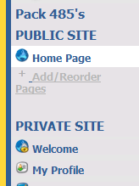

6. To change ScoutLander site information, click the Edit link in the top left corner of the page that appears.

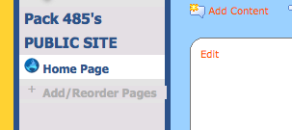

This opens a Microsoft Word type of editor. Make any changes you wish and be sure to click Save (top right corner) after making changes.

7. Attaching Documents

Once in edit mode, at the bottom of the page you can add documents by browsing through your files and add, then ensure to save.

8. Adding new scout members

Adding new scouts, adult leaders’ (Pack & Den leader) names can be done under the Site Setup Wizard link found at the bottom left of the page of step 5.

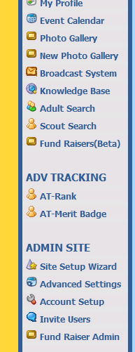

** SITE ADMINS & LEADERS – 2015/2016

Javier Foronda
Aaron Hottenstein
Christine Matthews
Jennifer Poitras
Becky Webb

** SITE LEADERS – 2015/2016

Heather Atkinson
Chris Swanson

