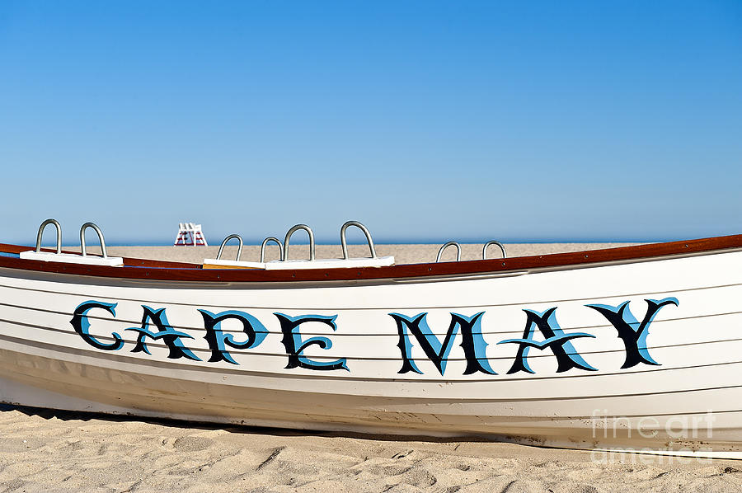

 ***CSA Overnight Trip***  Service Unit #90

Montclair North Branch Westfield www.gshnj.org

***April 23-24, 2016***

Saturday, April 23

Hotel - Icona Beach, 9701 Atlantic Avenue, Diamond Beach, 609-729-660; Confirmation # 27769; Guest Name: Scouts Girl; $132.08/room including applicable taxes; you are responsible for making your own reservation

Check in is not until after 3:00 pm so your troop can decide when you would like to check in based on the events listed below.

1:00-2:30 (approx.) Cape May Lighthouse & Cape May Point State Park ($1 per Scout / $4 per adult)

3:00-4:30 (approx.) Family Treasure Hunt in down-town Cape May / beach / Mall ($1 per packet – 1 packet for every 4-5 girls)

5:00-6:30 (approx.) Dinner Emlen Physick Estate, 1048 Washington Street, Cape May, NJ

7:00-7:30 (approx.) Stroll the Washington Street Mall & shops

7:30-8:00                  Ghosts of Cape May Trolley Tour ($10.25 per person)

Sunday, April 24

Cape May County Zoo 10:00 am – 4:45 pm Free

Wildwood Boardwalk – open 12:00 pm – 6:00 pm

Passport Around the Wheel, Wildwoods Convention Center - Girl Scouts will present displays for countries around the world. Travel from table to table and experience activities from different countries such as crafts, games, foods, etc. 1:00 - 3:30 p.m. Ticket prices: $7/girl; $1/adult

All these events are voluntary. RSVP to Patty (fafsmith@verizon.net) or Julia (jyotcoski@comcast.net) by April 1, 2016 so reservations can be made.